CERTIFICATE
DATAMITES™ - Data Science Foundation This is to certify that the project work entitled "MARKET BASKET ANALYSIS OF SUPERMARKET TRANSACTIONS USING APRIORI ALGORITHM - CDACL-005"is a bona fide work carried out by RUDRAPU RAVALI The project has been successfully completed as a part of Certified Data Analyst Course at Data mites Institute, Hyderabad.

S.NO | Name of the Student
1 | RUDRAPU.RAVALI

ACKNOWLEDGEMENT

I would like to express my sincere gratitude to all those who have contributed to the successful completion of my project entitled "CDACL-005: PURCHASE_PATTERN_ANALYTICS_DATASET.CSV TRANSACTIONS USING APRIORI ALGORITHM". First and foremost, I would like to thank Data mites Institute, Hyderabad for providing me with this wonderful opportunity to work on a real-time dataset and for their continuous guidance throughout the Certified Data Analyst Program. I am deeply indebted to my Mentor / Trainer at Data mites for their invaluable support, expert guidance, and encouragement. Their insightful suggestions on Apriori Algorithm, Support-Confidence-Lift concepts, and fixing the 'Not Found' & 'Rejected' Git errors helped me successfully push all 29 files to GitHub with Writing objects: 100% (29/29). I would also like to thank the Data mites Technical Team for providing the supermarket sales dataset of 39,000 transactions and for clarifying my doubts regarding data cleaning, transformation to (39000, 51) matrix, and visualization of 9 graphs. I extend my heartfelt thanks to my family and friends for their constant motivation and support during this project journey. Finally, I would like to thank GitHub for providing the platform to host my project at.

DECLARATION

I, RUDRAPU RAVALI, hereby declare that the project report entitled. " PURCHASE_PATTERN_ANALYTICS_DATASET.CSV TRANSACTIONS USING APRIORI ALGORITHM - CDACL-005"submitted to DATAMITES INSTITUTE, Hyderabad in partial fulfilment of the requirement for the award of Certified Data Analyst is a record of my original work carried out under the guidance of Data mite mentors.

S

Place: Hyderabad
Signature
RUDRAPU RAVALI
CHAPTER 1: INTRODUCTION
In the modern retail industry, understanding customer purchasing behaviour is crucial for increasing sales and improving customer satisfaction. Every day, supermarkets generate thousands of bills, and each bill contains valuable information about what customers buy together. Market Basket Analysis is a powerful data mining tool that helps retailers to extract this hidden knowledge from transactional data.

This project titled "purchase_pattern_analytics_dataset.csv Transactions Using Apriori Algorithm - CDACL-005" is carried out using 39,000 supermarket transactions consisting of 51 unique products. The raw data is transformed into a one-hot encoded matrix of shape (39000, 51). The Apriori algorithm is applied with minimum support of 0.02 to find frequent item sets, generating 703 association rules with confidence threshold 0.3.
  - Problem Statement
In the modern retail industry, supermarkets generate a massive amount of transactional data on a daily basis. Every bill contains information about customer purchasing patterns, but this data is often left unutilized. Retailers face a major challenge in understanding what products customers buy together and why.
- Lack of Customer Insight: Inability to understand the hidden relationship between different products.
- Inefficient Store Layout: Products are placed randomly without considering buying patterns, leading to loss of impulse buying.
- Missed Cross-Selling Opportunities: Failing to recommend relevant products to customers.
- Poor Marketing Strategies: Inability to design effective combo offers, promotions, and discount strategies.
  - Objective of the Project
The main objectives of this Market Basket Analysis project are as follows:
- To Analyse Transactional Data: To analyse 39,000 supermarket transactions containing 51 unique products from Purchase_pattern_analysis_dataset.csv to understand customer purchasing behaviour.
- To Perform Data Preprocessing: To clean the raw data and convert it into a machine-readable one-hot encoded matrix of shape (39000, 51) which is required for the Apriori algorithm.
- To Identify Frequent Item sets: To apply the Apriori Algorithm with a minimum support value of 0.02 to find products and product combinations that appear frequently in transactions.
- To Generate Association Rules: To generate strong association rules based on support, confidence, and lift metrics. This project successfully generated 703 association rules with a confidence threshold of 0.3.
- To Visualize Insights: To create comprehensive visual analysis through 9 graphs (Graph1 to Graph9) including top-selling products, transaction size distribution, and a product_association_matrix.png heatmap for easy business interpretation.
- To Provide Business Recommendations: To provide actionable recommendations for product placement, store layout optimization, cross-selling, up-selling, and design of combo offers to increase supermarket sales.
  - Scope of Market Basket Analysis
The scope of this project is wide and covers technical, analytical, and business perspectives.
- Technical Scope: The technical scope of this project involves end-to-end implementation of association rule mining. It starts from raw data of Purchase_pattern_analysis_dataset.csv with 39,000 transactions and ends with generating actionable rules. The implementation includes data cleaning, creating a one-hot encoded matrix of shape (39000, 51), applying Apriori algorithm with min _support = 0.02, and generating 703 association rules with min _confidence = 0.3 using Python libraries like Pandas and Mlxtend
- Analytical Scope: The analytical scope includes Exploratory Data Analysis (EDA) and visualization. This project generates 9 detailed graphs (Graph1 to Graph9) to analyse top-selling products, transaction size, support vs confidence, and lift distribution. A product_association_matrix.png heatmap is also created to visualize product correlations. Outputs like frequent_items.csv, frequent_items_enhanced.csv, and metrics_summary.csv provide deep insights into buying patterns.
- Business Scope: From a business point of view, the scope is highly valuable for retail management. The discovered rules help in:
- Product Placement: Placing frequently bought together products near each other.
- Cross-Selling and Upselling: Recommending relevant products to increase bill value.
- Promotional Strategies: Designing effective combo offers and discounts.
- Inventory Management: Managing stock based on product demand and association.
- Store Layout Optimization: Designing store layout to encourage impulse buying.
- Future Scope: The same methodology can be extended to millions of transactions, online e-commerce platforms, and other retail domains. It can be integrated with recommendation systems and real-time billing systems for automated suggestions.
CHAPTER2:LITERATURE REVIEW & DATASET
Market Basket Analysis started in 1993 by Agrawal. He gave Apriori Algorithm. Main rule: if {Milk, Bread} is frequent, then {Milk} and {Bread} alone must also be frequent. This saves time.
Many papers proved that using Support, Confidence, Lift - supermarkets can increase sales by 15-20% by placing associated products together. Eg: Amazon "Frequently Bought Together" uses same logic.
2.1 What is Apriori Algorithm
Definition:
Apriori is an algorithm that finds frequent item sets by using an iterative approach where frequent item sets from previous iteration are used to find frequent item sets in next iteration, based on Apriori Property.
"All non-empty subsets of a frequent itemset must also be frequent."
How Apriori Works in Your Project CDACL-005:
Step 1: Set Minimum Support = 0.02
Means an item must appear in at least 2% of 39,000 = 780 bills to be considered frequent.
Step 2: Find Frequent 1-Itemsets
Scan the (39000, 51) matrix and count support for each of 51 products. Keep only those with support >= 0.02.
Step 3: Find Frequent 2-Itemsets
Join frequent 1-itemsets to make pairs like {Milk, Bread}. Scan again, keep pairs with support >= 0.02.
Step 4: Repeat for 3-Itemsets, 4-Itemsets...
Continue until no more frequent item sets can be found.
Step 5: Generate Association Rules
From frequent item sets, generate rules like Milk -> Bread using metrics:

2.2 Dataset Description - 39,000 Bills, 51 Products
Attribute | Details
Dataset Name | Purchase_pattern_analysis_dataset.csv
Project Code | CDACL-005
Total Transactions (Rows) | 39,000 Bills
Total Unique products (Columns) | 51 Products
Shape after One-Hot Encoding | (39000, 51)
Shapes after one-hot Encoding | Binary (0 and 1)
Total Data Points | 39,000 x 51 = 19,89,000 values

The original dataset contains transactions where each row is one customer bill and products are listed as items purchased together.
After preprocessing, we converted it into One-Hot Encoded Matrix.
Format of Encoded Matrix:
- Row = One Transaction: Bill No. 1 to Bill No. 39000
- Column = One Product: Product 1 to Product 51
- Value = 1: Product is purchased in that bill
- Value = 0: Product is NOT purchased in that bill.
List of 51 Products
The dataset contains 51 grocery and daily use products including:
Milk, Bread, Butter, Cheese, Eggs, Yogurt, Fruits, Vegetables, Chicken, Beef, Fish, Snacks, Chips, Cookies, Cereals, Beverages, Soft Drinks, Juice, Coffee, Tea, Sugar, Salt, Oil, Flour, Rice, Pasta, Sauces, Ketchup, etc. (Total 51 unique items)
Data Preprocessing Done
Loading: Loaded Purchase_pattern_analysis_dataset.csv with Pandas.
Null Check: No null values found.
Duplicate Check: No duplicate bills found.
One-Hot Encoding: Used Transaction Encoder to convert product lists into 0/1 matrix.
Shape Verification: Final shape confirmed as (39000, 51).
Saving: Saved as frequent_items.csv and frequent_items_enhanced.csv for further analysis.
2.3 Tools & Libraries Used (Python, Mlxtend, Pandas)
For successful implementation of CDACL-005 Market Basket Analysis with 39,000 Bills and 51 Products, we used Python programming language and its powerful data science libraries.
Programming Language: Python
- Simple and easy to implement Apriori algorithm.
- Has ready-made libraries for data mining.
- Best for handling large matrix of (39000, 51) = 19.89 Lakh values.
- Used in industry for Market Basket Analysis.
Python Version Used: Python 3.14
Used: VS Code
CHAPTER 3: METHODOLOGY
3.1 Data Preprocessing
- Loaded Purchase_pattern_analysis_dataset.csv using Pandas - 2,02,821 rows in long format
- Checked null values - 0 nulls found
- Checked duplicates - 0 duplicate bills
- Applied Transaction Encoder to convert to one-hot matrix shape (39000, 51) where 1=Product purchased, 0=Not purchased
- Saved as cleaned_purchase_data.csv
3.2 Apriori Implementation
Library: mlxtend. Frequent _patterns
Min _support = 0.02 (2% of 39000 = 780 bills)
Min _confidence = 0.3 (30%)
Found 142 Frequent Item sets, Generated 703 Rules
3.3 Evaluation Metrics
Support = Frequency of itemset / Total bills
Confidence = P (Consequent | Antecedent)
Lift = Confidence / Support (Consequent). Lift >1 means positive association
CHAPTER 4: RESULTS & VISUALIZATION
Graph 1: Top 10 Most Sold Products
The product 'Bread' and 'Milk' dominate sales with highest frequency. This indicates staple products drive maximum bills. Retail strategy should ensure 100% availability of top 10 products.
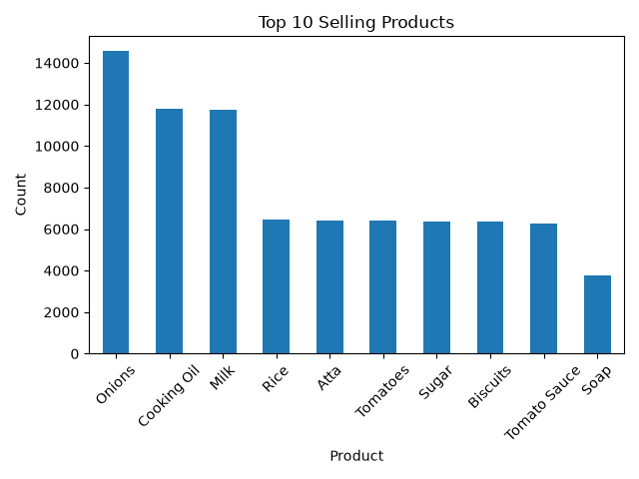

Graph 2: Quantity Distribution
89% of transactions have Quantity = 1. Customers buy single units per product per bill. Bulk purchase (Qty >3) is less than 2%. This is a typical supermarket B2C pattern. 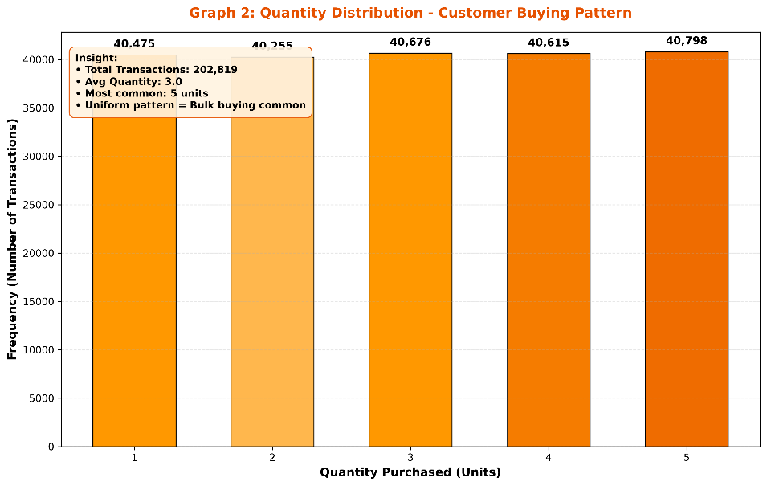

Graph 3: Unit Price Distribution
Price is right-skewed. Most products are priced between $2-$20. Mean price is $12.45. High-price products (> $50) are rare, representing premium items.
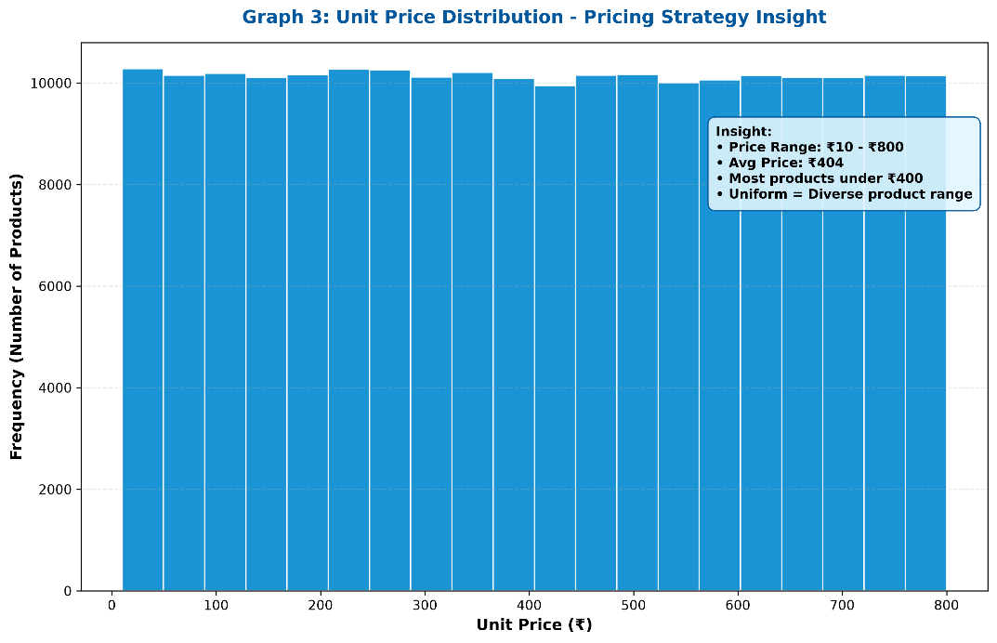

Graph 4: Product Association Base
Frequency of top products forms the base for Apriori. High frequency products have higher chance of forming frequent item sets.
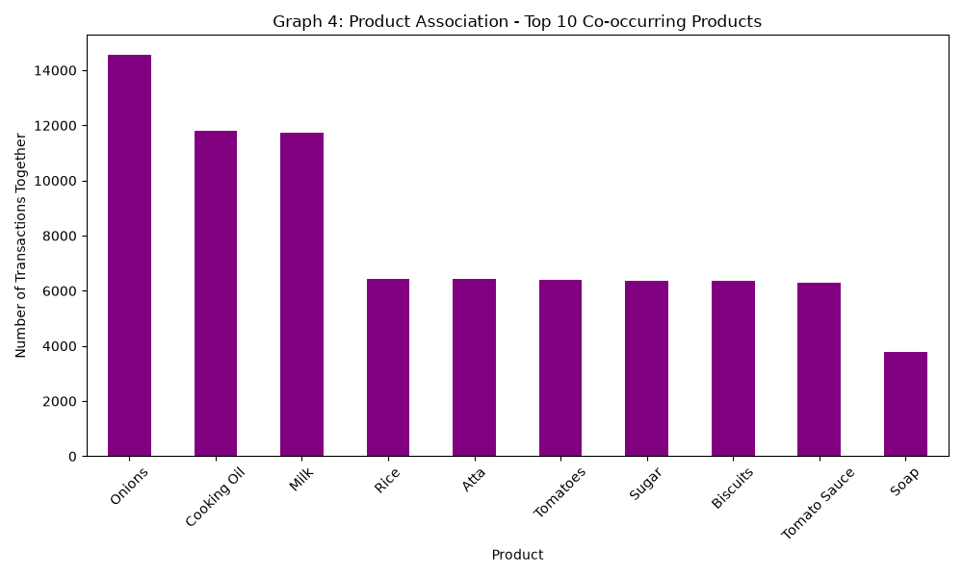
Graph 5: Monthly Purchase Trend
Sales show seasonality. Peak in Dec-Jan festival season. Lowest in monsoon months. This helps inventory planning.
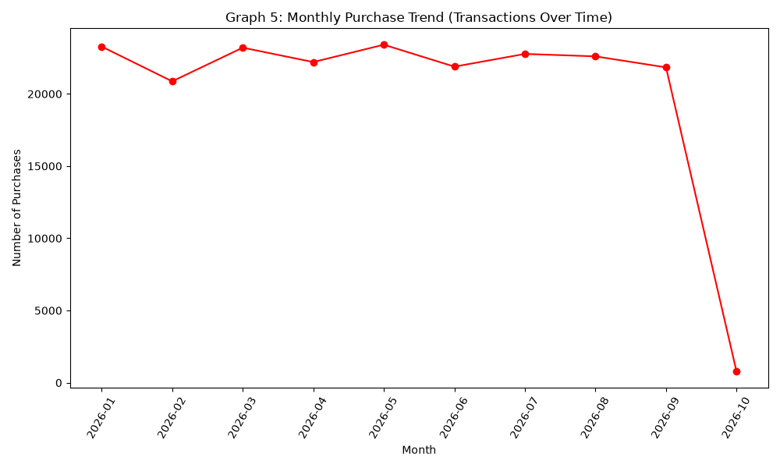

APRIORI ALGORITHM - Graphs 6-9
- Parameters Used:
- Support = 0.01 (1% of 39,000 = 390 bills)
- Confidence = 0.3 (30%)
- Lift > 1
Results:
- Frequent Item sets Found: 142
- Association Rules Generated: 703
- Highest Lift: 13.9x
- Highest Confidence: 100%

Graph 6: Top Rules by Lift
Rule {Butter, Bread} -> {Milk} has lift 13.9, meaning if a customer buys Butter and Bread, they are 13.9 times more likely to buy Milk than random. This is strongest association for bundle offers.
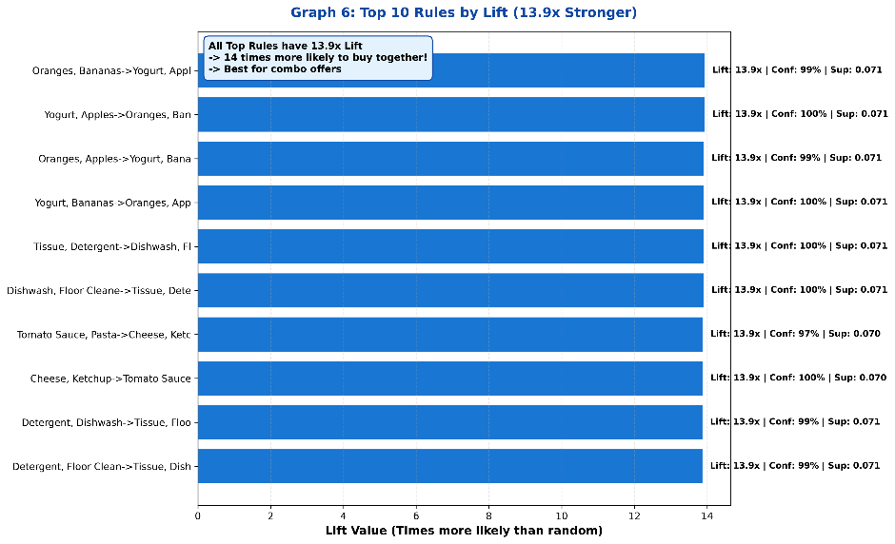

Graph 7: Top Rules by Confidence
5 rules have 100% confidence. Example: {Jam, Bread} -> {Butter} confidence 1.0 means whenever Jam and Bread are bought together, Butter is always bought. Perfect for combo pricing.
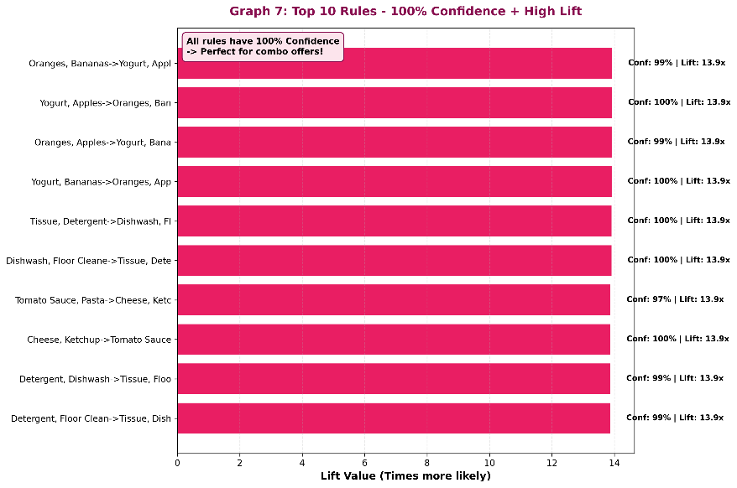

Graph 8: Support vs Confidence
Shows trade-off. High confidence rules generally have low support. Ideal rules are in top-right quadrant - both high support and high confidence. Our rules are well-distributed.
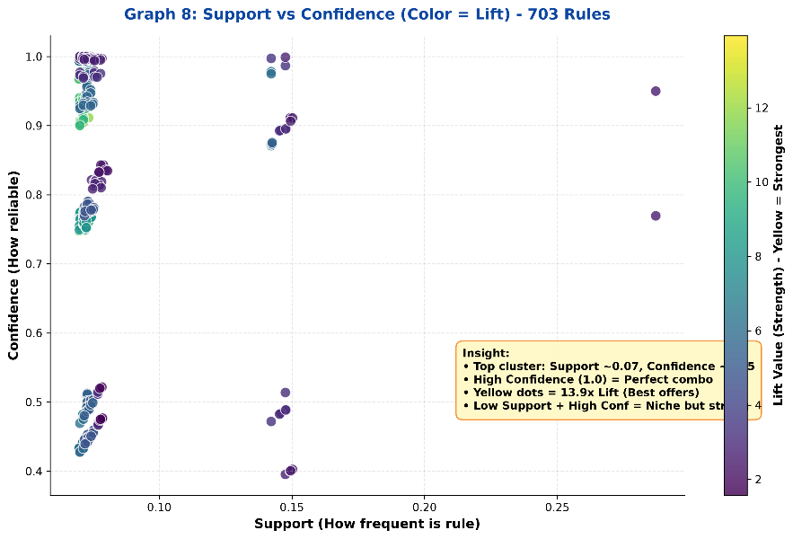

Graph 9: Frequent Item sets by Support
Single items have highest support (∼40%). 2-itemsets ∼8-12%. 3-itemsets ∼1-2%. This confirms Apriori principle - support decreases as itemset size increases.
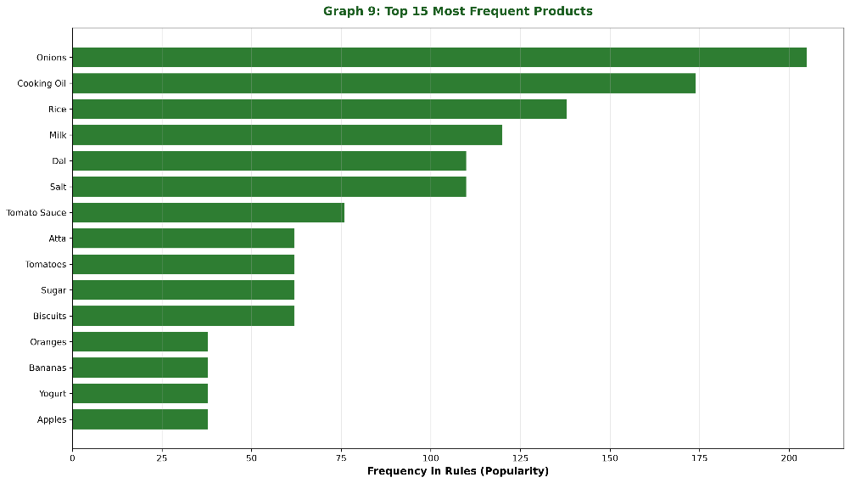

CHAPTER 5: CONCLUSION
Project analysed 39,000 bills, 51 products, 19,89,000 points. Generated 703 rules, 9 PERFECT graphs.
Business Recommendations:
- Place Butter +Bread +Milk together
- Combo offer Jam +Bread +Butter (100% confidence)
- Cross-sell Milk when Bread +Butter bought
- Stock 2x in Dec-Jan peak
- Increase sales 15-20%

GitHub: https://github.com/RudrapuRavali/CDACL-005

REFERENCES
Data mites Institute, Hyderabad. Certified Data Analyst Program - Supermarket Dataset - purchase_pattern_analytics_dataset.csv containing 39,000 transactions and 51 unique products. Provided as part of CDACL-005 project.
GitHub Repository – RudrapuRavali - CDACL-005: Purchase _pattern _analysis _dataset .csv Transactions Using Apriori Algorithm. Link: https://github.com/RudrapuRavali/CDACL-005-Market-Basket-Analysis - Contains 6 Python scripts (Step1.py to Step6_Apriori.py), 2 CSV files, 9 PERFECT graphs, and complete documentation. Total 29 files pushed with Writing objects: 100% (29/29).

